June 16th and 17th
Chef Ryan Damasky of Fish Restaurant
Co-hosted by Will Doyle of Pioneer Wines

AMUSE
Scallop Sashimi
Miso Mostarda, Gaunciale, Arugala Flowers
Hubert Ciavelin, “Tete de Cuvee”, Cremant de Jura, France, NV
FIRST
Foie Gras Brulee
Cherry Gelee, Compressed Beet, Hungarian Custard, Brioche, Nasturium Oil
Raymond Usseglio & Fils, Chateneuf du Pape, Roussanne “Pure”, Rhone, France, 2014
SECOND
John Dory Arroser
Aqua Pazzo, Red Sorrel, Wild Mizuna, Confit Cinnamon Cup
Maison Pascal Clement, Bourgogne Blanc, France, 2015
THIRD
Mangalits
Smoked Shoulder, Goat Milk Polenta, Ground Cherry Sofrito, Green Strawberry and Hakurei Salad
Burn Cottage, “Cashburn” Pinot Noir, Central Ottago, New Zealand, 2015

DESSERT
Lemon Balm Mirror Cake
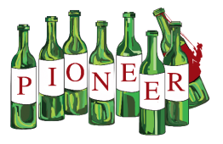
Burnt Honey Ice Cream, Preserved Lemon and Oat Crumble, Coconut Foam, Snap Dragons
Saracco, Moscato d’Asti, Piedmont, Italy, 2016

